Washington Panther Invite Course Map: 2 Miles

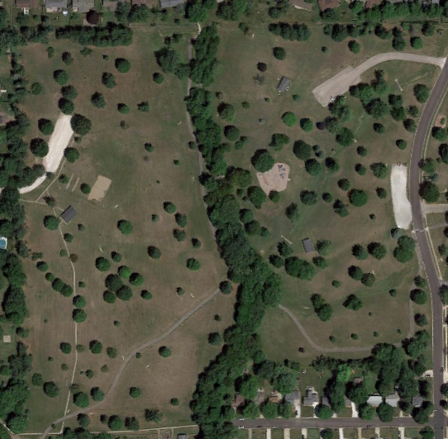

Start

1 Mile

Finish

1st mile -
2nd mile -

